**Brasch, (Orwell) Charles (1909 - 1973)**

Molly Hall, University of Rhode Island

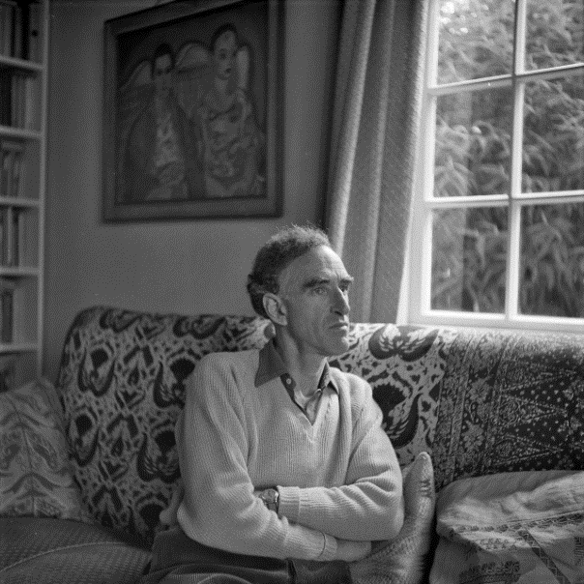**Charles Brasch at his home in Dunedin, 1960. Held by Hocken Collections, Uare Taoka o Hakena, University of Otago.**

(url: http://jewishonlinemuseum.org/charles-brasch)

Charles Brasch was a New Zealand poet, critic, editor, and translator. Primarily informed by national identity and history, his work focused on finding rootedness in the landscape of New Zealand for its European settlers. He is best known for his mid-to-late career poetry: *The Estate, and Other Poems* (1957), *Ambulando: Poems* (1964), and *Not Far Off: Poems* (1969). He was the founder and long-time editor of the leading literary journal, *Landfall,* and both a well-known trendsetter in, and patron of, the New Zealand Arts. Though he felt strongly connected to England, a country he spent much of his time in, he made his most significant literary contributions at home. On May 20, 1973, Brasch passed away after a battle with Hodgkin’s disease in the town of his birth, Dunedin, New Zealand.

Charles Brasch was born in Dunedin, New Zealand on July 27, 1909 to Hyam Brasch, a Jewish lawyer who changed his name to Henry to avoid discrimination, and Mary Fels, a woman of German descent related to affluent merchant families of New Zealand—such as the Hallensteins, about whom he later wrote a collaborative history with C.R. Nicholson. The young Brasch grew close with his grandfather, a man who instilled in him a love of European culture and encouraged him to pursue a career in the arts against his father’s wishes. He did not do well at Oxford, deepening his father’s disappointment, instead focusing on his writing by following the example of his contemporaries there—W. H. Auden and Cecil Day-Lewis—and publishing in respected student magazines. After graduating, he expanded his appreciation of art and literature while travelling with a cousin, of the De Beer family, in Italy. When he returned to Dunedin in 1932, a friend convinced him to participate in several archeological expeditions to Egypt with John Pendlebury, an experience that had a lasting impact on the themes of his writing long after his final return. Between digs, he attended the University of London School of Oriental Studies, learning the Egyptian and Arabic that would enable his later translation work.

After briefly leaving England to travel to Hawaii with his father at the outbreak of World War II, he returned to England—his adopted homeland—to serve during the war. Excused from active duty due to emphysema, he spent the war years in London doing fire watching, then intelligence work for the foreign office. At the war’s end he returned to Dunedin and founded the influential literary journal *Landfall* in 1946, editing it until his retirement in 1966. As the editor of *Landfall*, he guided the development of the national literature and cultural criticism of New Zealand, fueled by his desire to build an independent post-colonial culture which he insisted must depend heavily on the European tradition of its settlers’ origins.

[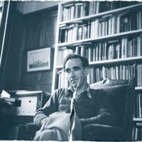](http://www.odt.co.nz/files/story/2009/03/charles_brasch_graphic_by_hayden_smith_from_image__1644740626.jpg)**Brasch in His Study, Graphic by Hayden Smith, Reference #: 1/4-019117;F, Alexander Turnbull Library, John Reece Cole Collection.**

(url: http://www.odt.co.nz/files/story/2009/03/charles_brasch_

graphic_by_hayden_smith_from_image__1644740626.jpg)

Brasch was self-conscious of his own homosexuality, which was something of an open secret. Aside from a short time spent living with Robert Kennedy, a Dunedin artist and theater producer, he had no known intimate relationships, and even about this relationship, little is known. He did have a handful of close friends, who surrounded him in his last days, as he continued to write poetry from his sickbed.

A very public figure in New Zealand arts, his work explored the theme of European settlement in New Zealand, like his fellow countryman A.R.D. Fairburn, but to Italian artistic ideals, despite his early work evincing his divided attachment to England and his homeland. His poetry was consistently concerned with identity, and particularly national identity. By the writing of *The Estate* (1957) he became preoccupied with the rediscovery of his native nation. His tone was elegiac and his style was lyrically profuse, but as he continued to write, around the publication of *Ambulando* (1964), his style grew tighter and more concise as his themes began to explore identity and individuality on a more global scale. In *Not Far Off* (1969), he struggles to make an internal identity coherent, yet fears its exposure, leading to a feeling in reading that something is still mournfully withheld. The poems of his final years dealt most notably with illness and aging, bringing the disabled or declining body into his work.

Throughout, one can find a struggle with the sense of isolation and rootlessness that the white settler might feel in his or her own homeland, searching for a shared sense of history as deep as the Maori indigenous inhabiting of the landscape before them, though the Maori also continued their residence alongside the white settlers. These explorations are shown, often, through descriptive evocations of the New Zealand landscape, depicting humanity at the nexus of place and time. After his retirement from *Landfall,* his involvement in linguistics and interest in travel continued, as he studied Russian, traveled to India to translate Punjabi poetry, and continued to guest lecture at universities and institutions throughout New Zealand, such as the University of Otago, until his death.

**Selected List of Works**

Collected Works

*The Universal Dance: A Selection from the Critical Prose Writings of Charles Brasch* (1981)

*Collected Poems* (1984)

Poetry

*The Land and the People, and Other Poems* (1939)

*Disputed Ground: Poems 1939-45* (1948)

*The Estate, and Other Poems* (1957)

*Ambulando: Poems* (1964)

*Not Far Off: Poems* (1969)

Short Story Collections

*Such Separate Creatures: Stories* (1973)

Drama

*The Quest: Words for a Mime Play* (1946)

Non-Fiction

*Present Company: Reflections on the Arts* (1966)

*Hallensteins: The First Century, 1873-1973* (1973) with C.R. Nicholson.

Translation Work

Pritam, Amrita (1967) *Black Rose,* New Delhi: Nagmani.

Esenin, Sergei Aleksandrovich (1970) *Poems by Esenin,* Wellington: Wai-te-ata Press.

Translated with Peter Soskice.

Published Posthumously

*Home Ground: Poems* (1974)

*Indirections: a Memoir, 1909-1947* (1980)

*Charles Brash in Egypt* (2007)

**Further Reading**

Bertram, James (1976) *Charles Brasch,* Wellington: Oxford University Press.

Milner, Ian (1971) ‘Conversation with Charles Brasch,’ *Landfall*,25.4, 344–372.

McNeish, James (2003) *Dance of the Peacocks: New Zealanders in exile in the time of Hitler*

*and Mao Tse Tung*, New York: Vintage.